Project Design Phase-II
Technology Stack (Architecture & Stack)

Date | 27 August 2026
Project Name | Employee Raise Issue
Maximum Marks | 4 Marks

Technical Architecture:
Technical Architecture is a diagram or structure that shows how different parts of a software application work together.The Employee Raise Issue system uses a web-based architecture where employees can log in and submit workplace issues through the Service Portal. The application processes the submitted issue and stores the details in the database. HR or managers can view, assign, update, and resolve the issues. The system sends notifications to employees whenever there are important updates. The application is hosted on the ServiceNow cloud platform, which provides security, data storage, and availability.
The Employee Raise Issue application is developed on the ServiceNow platform using Service Portal, Record Producer, Catalog Variables, a custom Employee Raise Issue table, Flow Designer, Business Rules, Client Scripts, ACLs, Notifications, and Reports. Employees submit issues through the Service Portal, the Record Producer creates the issue record, Flow Designer automates assignment and approval, and notifications keep employees and HR/Managers informed until the issue is resolved

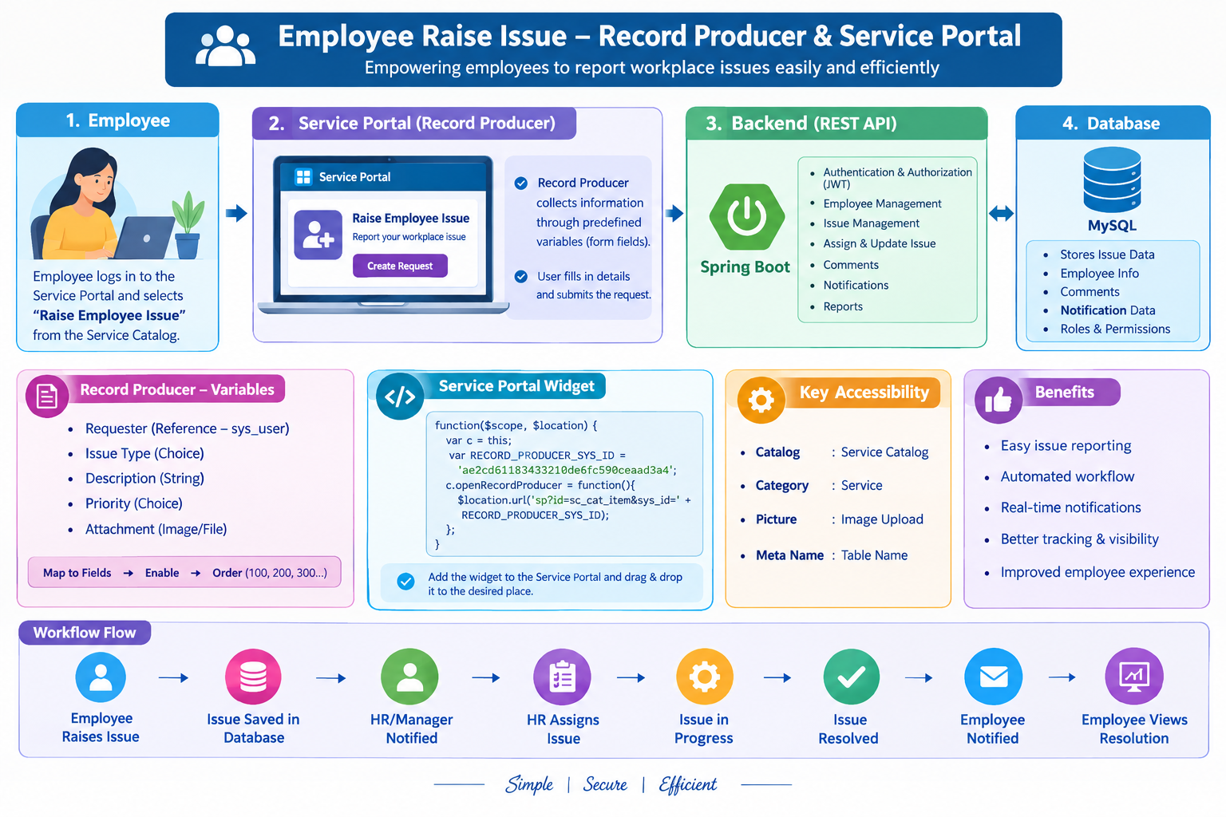Table-1 : Components & Technologies:

S.No | Component | Description | Technology
1 | User Interface | Employee uses the portal to raise and track issues. | HTML, CSS, JavaScript, ServiceNow Service Portal
2 | Application Logic-1 | Handles employee issue submission and creation. | ServiceNow
3 | Application Logic-2 | Handles issue assignment, tracking and status updates. | ServiceNow Flow Designer
4 | Application Logic-3 | Sends notifications to employees and HR/Managers. | ServiceNow Notifications
5 | Database | Stores employee, issue, status and assignment details. | ServiceNow Database
6 | Cloud Database | Stores application data in the cloud environment. | ServiceNow Cloud
7 | File Storage | Stores supporting files or attachments related to issues. | ServiceNow Attachments
8 | External API-1 | Can be used to send email notifications. | Email Service
9 | External API-2 | Optional API for additional employee services. | REST API
10 | Machine Learning Model | Not required for the basic Employee Raise Issue system. | Not Applicable
11 | Infrastructure (Server / Cloud) | Hosts and runs the application. | ServiceNow Cloud Platform

Table-2: Application Characteristics:

S.No | Characteristics | Description | Technology
1 | Open-Source Frameworks | Used for creating the user interface and web pages. | HTML, CSS, JavaScript
2 | Security Implementations | Only authorized users can access employee and issue information. | User Roles, ACLs, Authentication
3 | Scalable Architecture | The system can support more employees and issues as the organization grows. | ServiceNow Cloud Platform
4 | Availability | The application is available through the cloud platform for users when required. | ServiceNow Cloud
5 | Performance | The system provides quick issue submission, tracking and status updates. | ServiceNow, Flow Designer

